Kubernetes – 08
- Create and Test a Kubernetes Pod with an EmptyDir Volume

Explanation:
This task demonstrates how to use an emptyDir volume, which is temporary storage tied to the lifecycle of a pod. emptyDir volumes are initially empty and are created when a pod is assigned to a node. The lifetime of an emptyDir volume is the same as the pod that contains it. If the container inside the pod crashes and restarts, the data in the emptyDir remains. However, if the entire pod is deleted or crashes, the data in the emptyDir volume is lost.

YAMLs:
emptydir-pod.yaml
apiVersion: v1
kind: Pod
metadata:
name: emptydir-pod
spec:
containers:
name: nginx-container
image: nginx
volumeMounts:
mountPath: /data
name: my-emptydir-volume
volumes:
name: my-emptydir-volume
emptyDir: {}

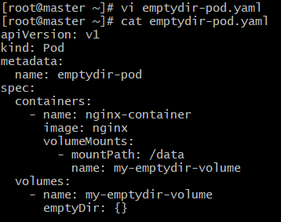

Commands:
kubectl apply -f emptydir-pod.yaml # Create the Pod
kubectl get pods emptydir-pod -w # Wait for pod to be running
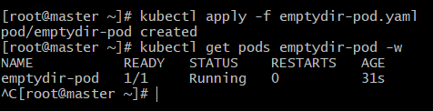

kubectl exec -it emptydir-pod -- /bin/bash # Login to container
# echo "This is data in emptyDir" > /data/testfile.txt # Create file
# ls /data # List files in volume

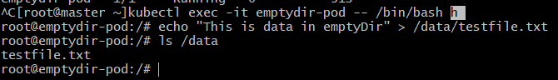

# mkdir /tmp/tempdata # Create temp directory
# echo "This is temporary data" > /tmp/tempdata/tempfile.txt # Create temp file
# ls /tmp/tempdata # List temp files
# exit # Exit container

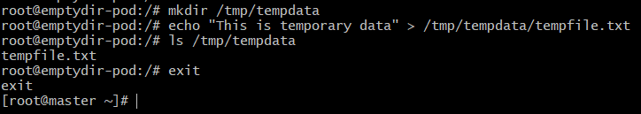

kubectl exec -it emptydir-pod -- /bin/bash -c "nginx -s stop" # Stop Nginx (restarts container)
kubectl exec -it emptydir-pod -- /bin/bash # Login to new container instance
# ls /data # Validate files in emptyDir
# cat /data/testfile.txt # Read content
# ls /tmp/tempdata # Check temporary files

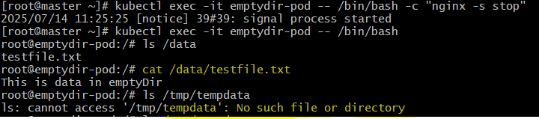

Purpose of the task:
This task illustrates that data stored in an emptyDir volume persists across container restarts within the same pod. However, it also highlights that the data is ephemeral and will be lost if the entire pod is deleted. This volume type is suitable for temporary storage, cache data, or shared scratch space for containers within the same pod.
- Configure a HostPath Volume in Kubernetes and Validate Data Persistence

Explanation:
This task demonstrates using a hostPath volume, which mounts a file or directory from the host node (the node where the pod is running) into a pod. Data on a hostPath volume persists even if the pod is deleted, as the data lives on the host's filesystem. However, it's bound to a specific node, which means if the pod is rescheduled to a different node, it will not have access to the original hostPath data, making it unsuitable for multi-node clusters without careful management.

YAMLs:
hostpath-pod.yaml
apiVersion: v1
kind: Pod
metadata:
name: hostpath-pod
spec:
containers:
name: nginx-container
image: nginx
volumeMounts:
mountPath: /data
name: my-hostpath-volume
volumes:
name: my-hostpath-volume
hostPath:
path: /tmp/k8s-hostpath-data
type: DirectoryOrCreate

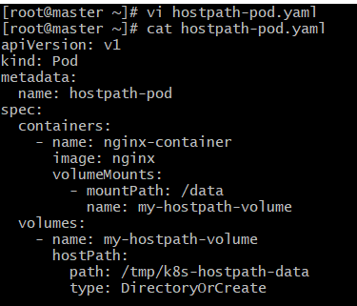

Commands:
kubectl apply -f hostpath-pod.yaml # Create the Pod
kubectl get pods hostpath-pod -o wide # Wait for pod to be running
kubectl exec -it hostpath-pod -- /bin/bash # Login to container
# echo "This is data on hostPath" > /data/hostfile.txt # Create file
# ls /data # List files
# exit # Exit container

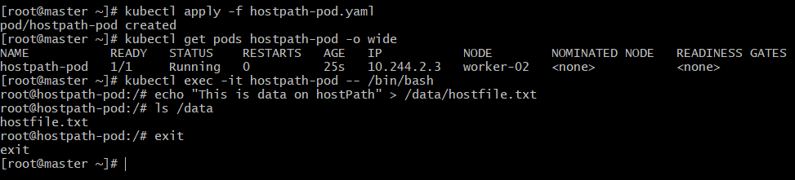

In worker node in which pod is running – (Worker-02)
# ls /tmp/k8s-hostpath-data # Check files on host
# cat /tmp/k8s-hostpath-data/hostfile.txt # Read host file

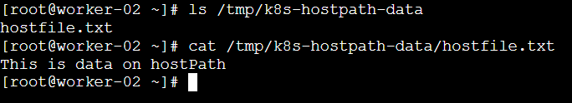

kubectl delete -f hostpath-pod.yaml # Delete the Pod
kubectl apply -f hostpath-pod.yaml # Create new pod
kubectl get pods hostpath-pod -o wide # Wait for new pod to be running
kubectl exec -it hostpath-pod -- /bin/bash # Login to new pod
# ls /data # Validate files in data directory
# cat /data/hostfile.txt # Read hostPath file
# exit # Exit container

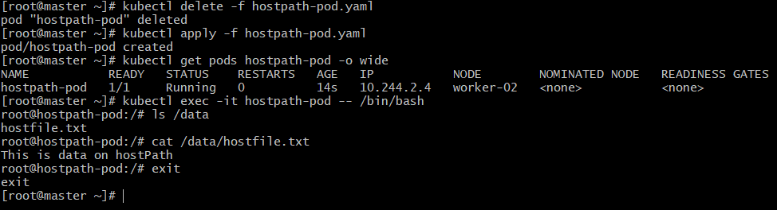

Purpose of the task:
This task demonstrates that hostPath volumes allow data to persist even after a pod is deleted and recreated, as the data resides on the underlying node. However, it also highlights the limitation: hostPath volumes are tied to a specific node, making them unsuitable for multi-node production environments where pods can be scheduled on any node.
- Deploy an Amazon EBS Volume Using Persistent Volume and Persistent Volume Claim (PVC)

Explanation:
This task outlines the process of integrating Amazon Elastic Block Store (EBS) with Kubernetes using the Container Storage Interface (CSI) driver. EBS provides block-level storage that can be attached to a single node at a time, making it suitable for stateful applications requiring dedicated storage like databases. Persistent Volumes (PVs) and Persistent Volume Claims (PVCs) abstract the underlying storage details from the pods, allowing flexible storage management.

Prerequisites and Configuration:
AWS Account and K8s Cluster: Ensure you have an AWS account and a multi-node Kubernetes cluster running in AWS.
Create an EBS Volume:
Login to AWS Console -> EC2 -> Volumes.
Create a gp2 or gp3 volume of 10 GiB in the same Availability Zone as your K8s nodes.
Note down the Volume ID (e.g., vol-0abcdef1234567890).
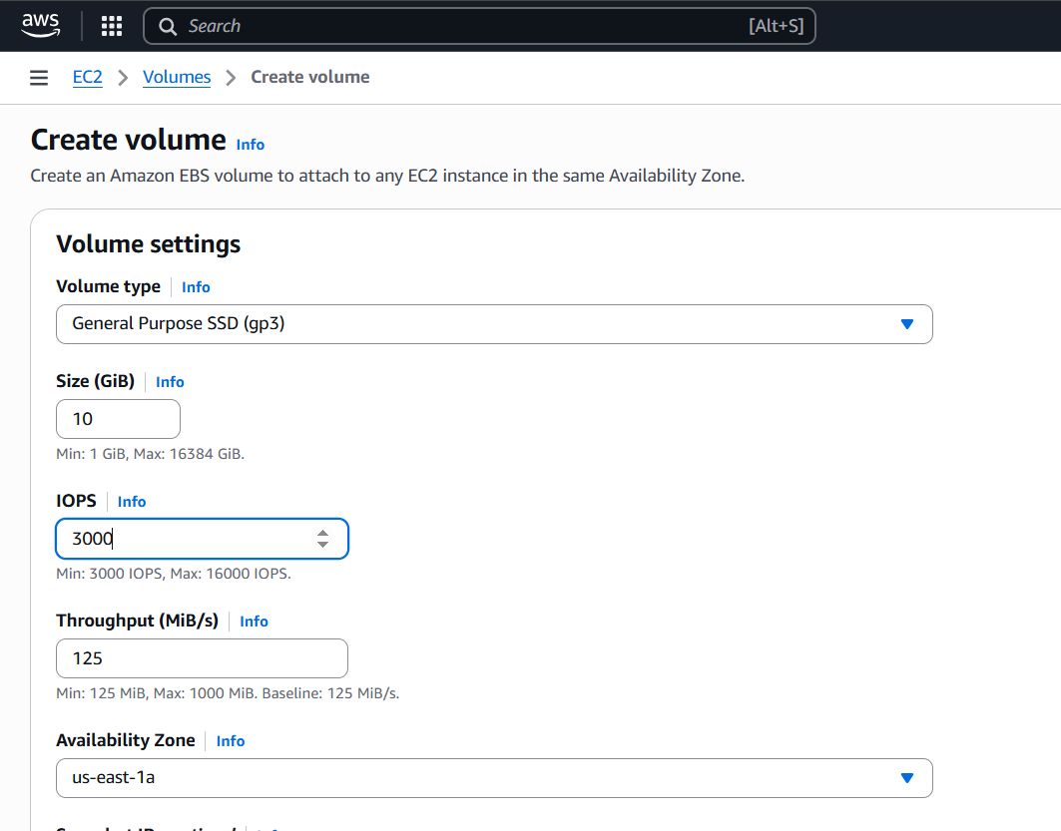
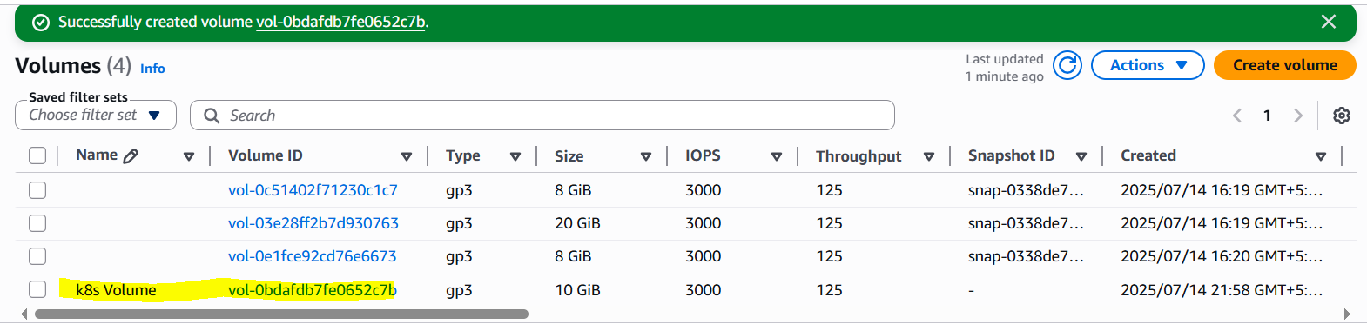

Create IAM Role for AWS EBS CSI Driver:
Go to IAM -> Roles.
Create a new EC2 role and attach the AmazonEBSCSIDriverPolicy.
Attach this IAM role to all your Kubernetes EC2 worker nodes.
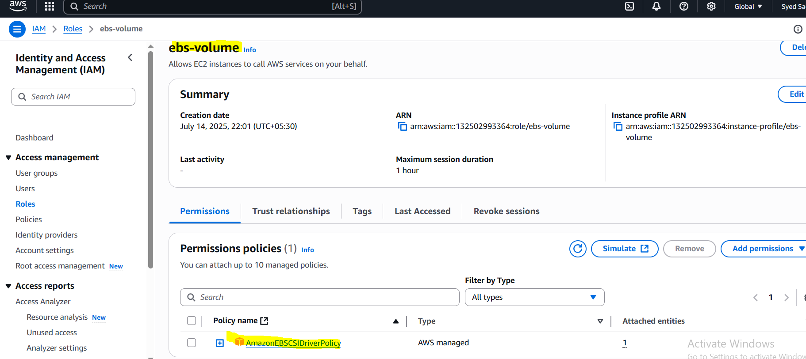
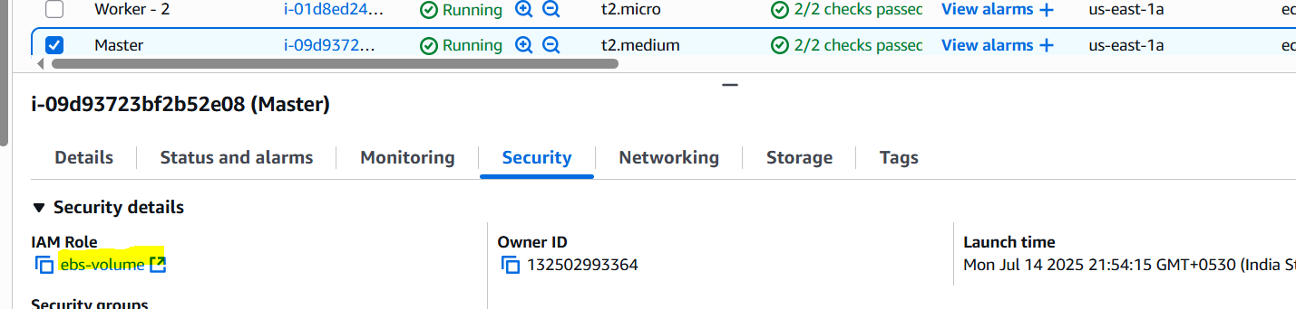
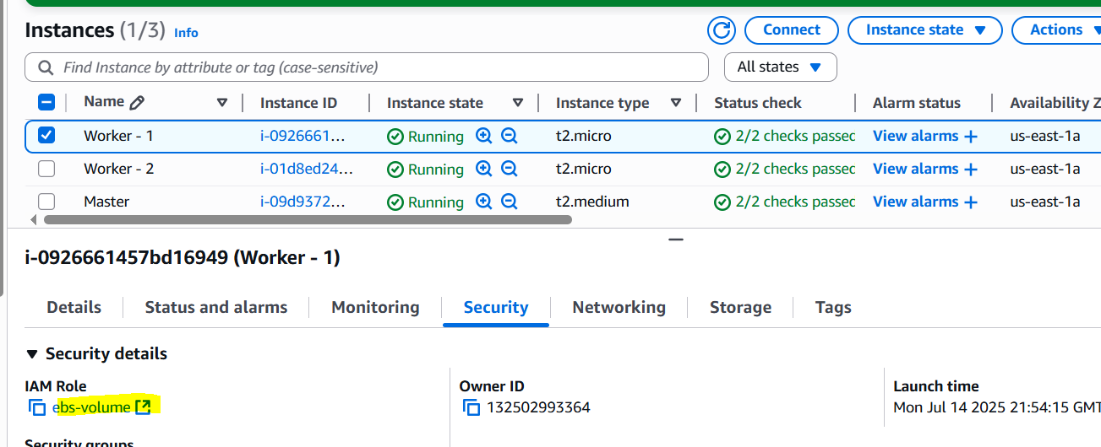
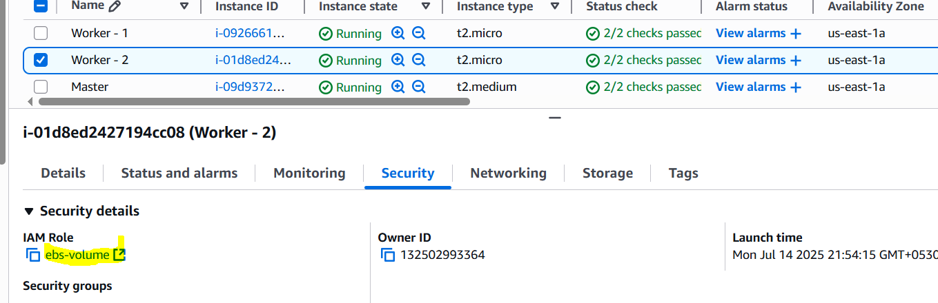

Install AWS EBS CSI Driver on K8s Master Node:
git clone https://github.com/kubernetes-sigs/aws-ebs-csi-driver.git
cd aws-ebs-csi-driver
kubectl apply -k deploy/kubernetes/overlays/stable/
kubectl get pods -n kube-system -l app.kubernetes.io/name=aws-ebs-csi-driver # Verify driver

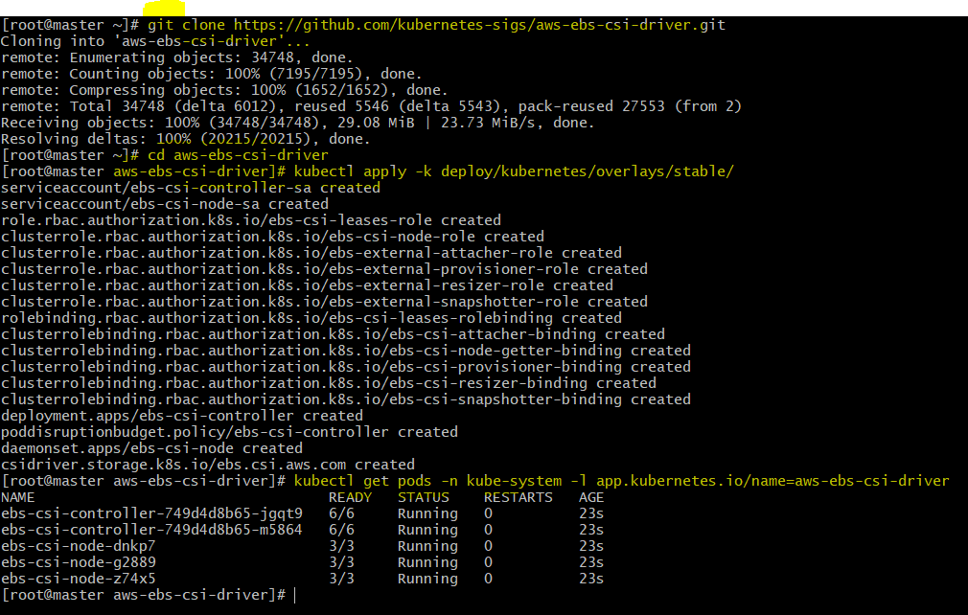

YAMLs:
ebs-pv.yaml
apiVersion: v1
kind: PersistentVolume
metadata:
name: my-ebs-pv
spec:
capacity:
storage: 10Gi
accessModes:
ReadWriteOnce
persistentVolumeReclaimPolicy: Retain
storageClassName: aws-ebs
awsElasticBlockStore:
volumeID: <your-ebs-volume-id> # REPLACE THIS
fsType: ext4

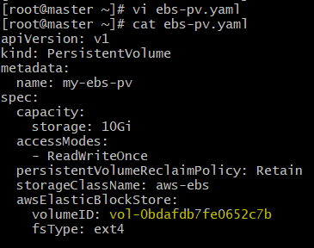
ebs-pvc.yaml
apiVersion: v1
kind: PersistentVolumeClaim
metadata:
name: my-ebs-pvc
spec:
accessModes:
ReadWriteOnce
resources:
requests:
storage: 10Gi
storageClassName: aws-ebs

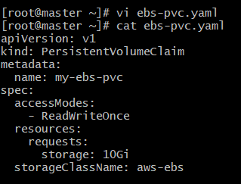
ebs-pod.yaml
apiVersion: v1
kind: Pod
metadata:
name: my-ebs-pod
spec:
containers:
name: my-ebs-container
image: nginx
volumeMounts:
name: data-volume
mountPath: /data
volumes:
name: data-volume
persistentVolumeClaim:
claimName: my-ebs-pvc

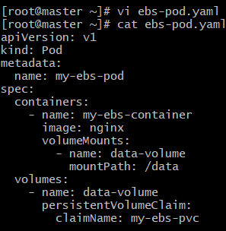

Commands:
kubectl apply -f ebs-pv.yaml # Create PV
kubectl apply -f ebs-pvc.yaml # Create PVC
kubectl get pv # Verify PV status
kubectl get pvc # Verify PVC status
kubectl apply -f ebs-pod.yaml # Create Pod
kubectl get pods my-ebs-pod -o wide # Wait for pod to be running

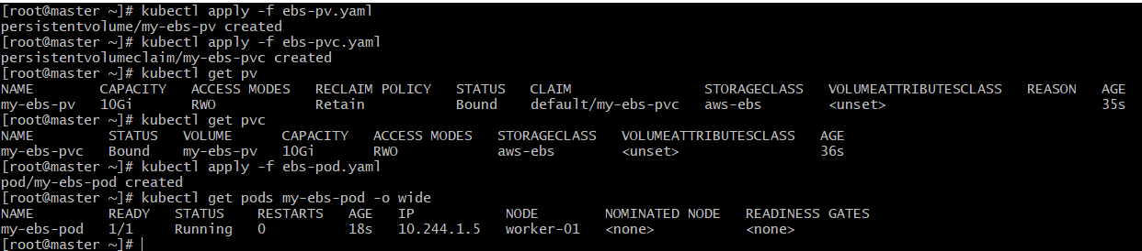

kubectl exec -it my-ebs-pod -- /bin/bash # Login to container
# echo "This is data on EBS" > /data/ebsfile.txt # Create file
# ls /data # List files
# exit # Exit container

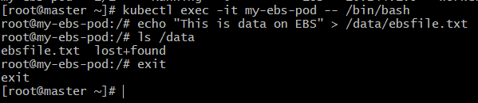

# Check AWS EC2 console, Volumes section # Check EBS volume status
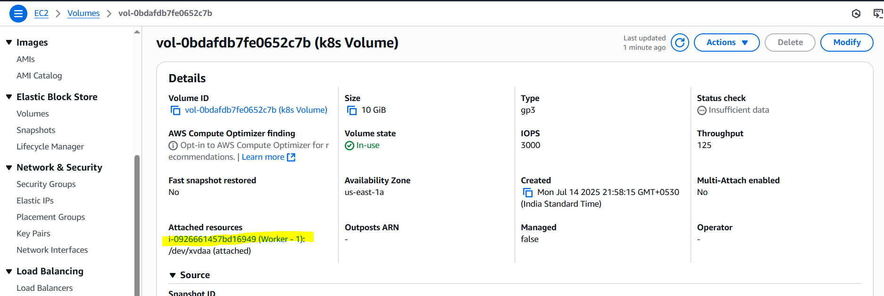

kubectl delete -f ebs-pod.yaml # Delete Pod
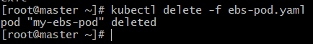

# Check AWS EC2 console, Volumes section # Observe EBS status after deletion
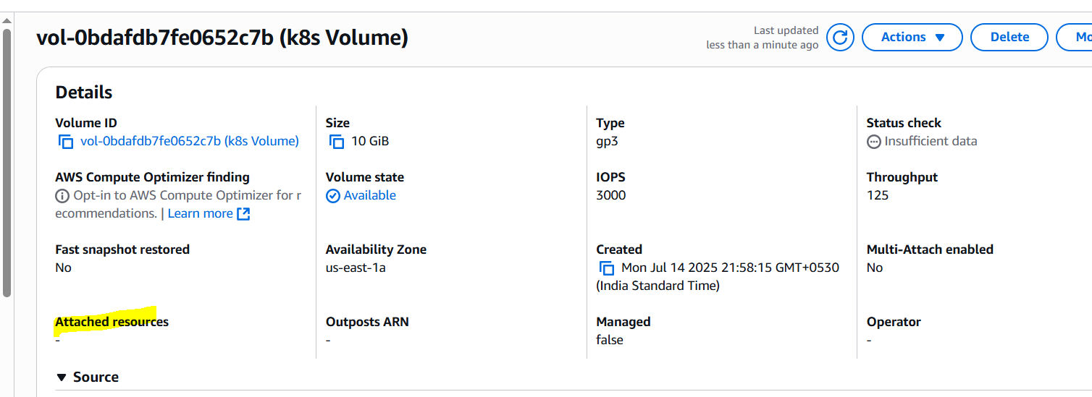

kubectl apply -f ebs-pod.yaml # Create new pod
kubectl get pods my-ebs-pod -o wide # Wait for new pod
kubectl exec -it my-ebs-pod -- /bin/bash # Login to new pod
# ls /data # Validate files
# cat /data/ebsfile.txt # Read file
# exit # Exit container

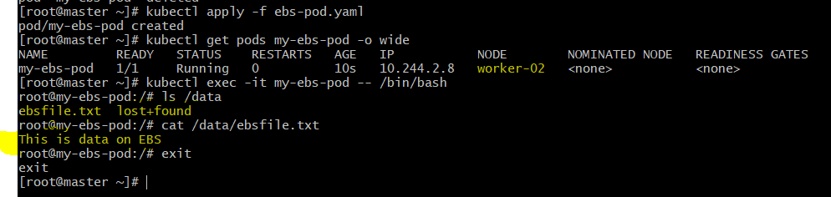

Purpose of the task:
This task demonstrates how to provision and manage persistent storage using Amazon EBS in a Kubernetes cluster. By leveraging Persistent Volumes (PVs) and Persistent Volume Claims (PVCs), applications can request and utilize dedicated block storage that persists independently of pod lifecycles. This is crucial for stateful applications like databases, where data integrity and persistence are paramount. The ReadWriteOnce access mode of EBS means it can only be attached to a single node at a time.

- Set Up an Amazon EFS Volume and Attach it to Multiple Pods

Explanation:
This task demonstrates the integration of Amazon Elastic File System (EFS) with Kubernetes using the CSI driver. EFS provides a highly scalable, elastic, and shared file system that can be accessed by multiple Kubernetes pods concurrently. This is especially useful for distributed applications that need to share common data across multiple pods and nodes.

Prerequisites and Configuration:
AWS Account and K8s Cluster: Ensure you have an AWS account and a multi-node Kubernetes cluster running in AWS.
Create an EFS File System:
Login to AWS Console -> EFS -> File systems.
Create a file system in your cluster's VPC and desired Availability Zones.
Note down the File system ID (e.g., fs-0abcdef1234567890).
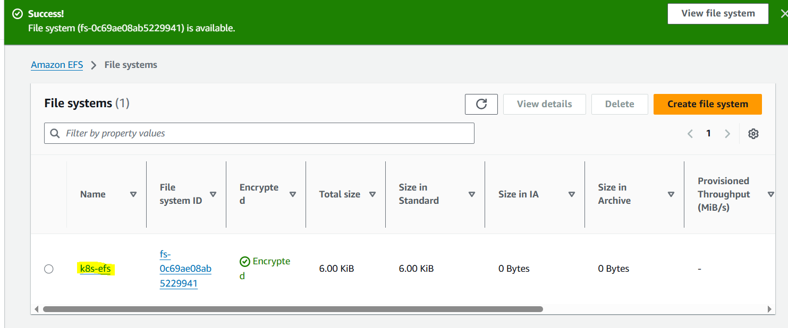
fs-0c69ae08ab5229941
Create an EFS Access Point (Recommended):
In the EFS console, select your file system -> Access points tab.
Create an access point with a Root directory path (e.g., /myk8sdata) and optional POSIX user.
Note down the Access point ID (e.g., fsap-0abcdef1234567890).
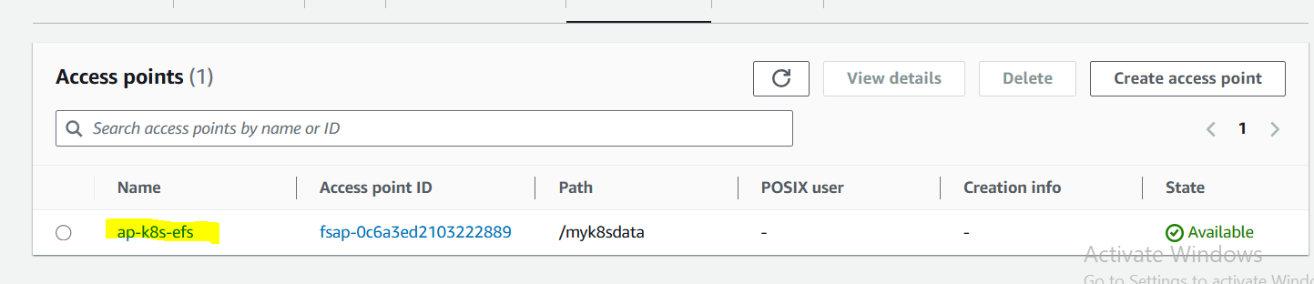
fsap-0c6a3ed2103222889
Add IAM role and attach to all nodes:
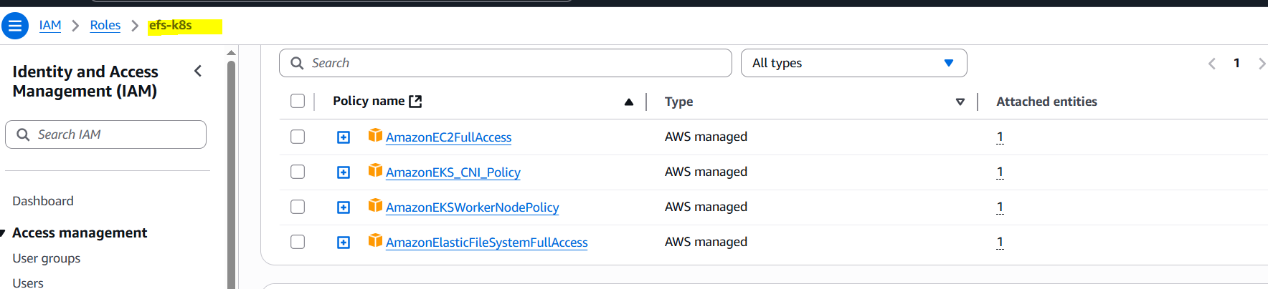
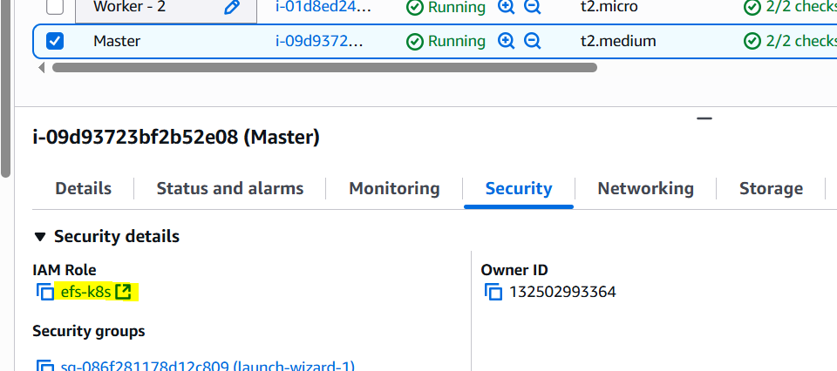

Install AWS EFS CSI Driver on K8s Master Node:
git clone https://github.com/kubernetes-sigs/aws-efs-csi-driver.git
cd aws-efs-csi-driver/deploy/kubernetes/overlays/stable/
kubectl apply -k .
kubectl get pods -n kube-system -l app=efs-csi-controller # Verify controller
kubectl get pods -n kube-system -l app=efs-csi-node # Verify node driver

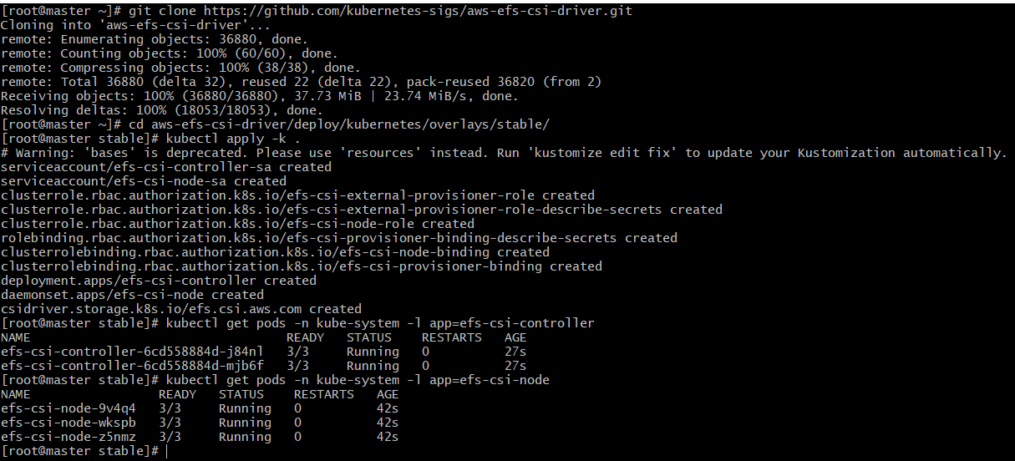

YAMLs:
efs-storageclass.yaml
apiVersion: storage.k8s.io/v1
kind: StorageClass
metadata:
name: efs-sc
provisioner: efs.csi.aws.com
parameters:
provisioningMode: efs-ap
fileSystemId: <your-efs-file-system-id> # REPLACE THIS
directoryPerms: "777"
accessPointId: <your-efs-access-point-id> # REPLACE THIS (if using Access Point)

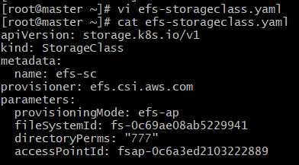
efs-pvc.yaml
apiVersion: v1
kind: PersistentVolumeClaim
metadata:
name: efs-pvc
spec:
accessModes:
ReadWriteMany
storageClassName: efs-sc
resources:
requests:
storage: 5Gi

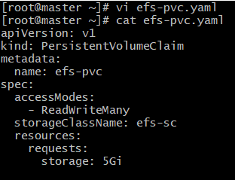
efs-pod-1.yaml
apiVersion: v1
kind: Pod
metadata:
name: efs-pod-1
spec:
containers:
name: my-app-1
image: nginx
volumeMounts:
name: efs-volume
mountPath: /efs-mount
volumes:
name: efs-volume
persistentVolumeClaim:
claimName: efs-pvc

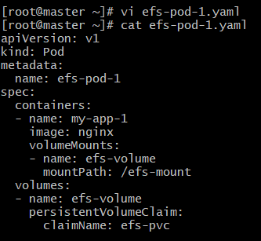
efs-pod-2.yaml
apiVersion: v1
kind: Pod
metadata:
name: efs-pod-2
spec:
containers:
name: my-app-2
image: nginx
volumeMounts:
name: efs-volume
mountPath: /efs-mount
volumes:
name: efs-volume
persistentVolumeClaim:
claimName: efs-pvc

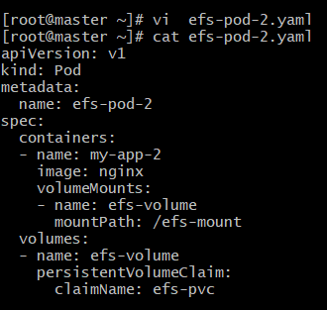

Commands:
kubectl apply -f efs-storageclass.yaml # Create Storage Class
kubectl apply -f efs-pvc.yaml # Create PVC

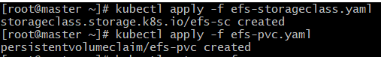

kubectl get pvc efs-pvc # Verify PVC status
kubectl get pv # Verify dynamically provisioned PV

kubectl apply -f efs-pod-1.yaml # Create first Pod
kubectl get pods efs-pod-1 -o wide # Wait for first pod

kubectl exec -it efs-pod-1 -- /bin/sh # Login to first pod
# echo "Hello from Pod 1" > /data/pod1_message.txt # Create file
# echo "Shared data test" > /data/shared_file.txt # Create another file
# ls /data # List files
# exit # Exit container

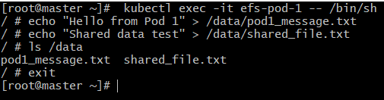

kubectl apply -f efs-pod-2.yaml # Create second Pod
kubectl get pods efs-pod-2 -o wide # Wait for second pod

kubectl exec -it efs-pod-2 -- /bin/sh # Login to second pod
# ls /efs-mount # List files (should see pod1's)
# cat /efs-mount/pod1_message.txt # Read file from pod 1
# echo "Hello from Pod 2" > /efs-mount/pod2_message.txt # Create file
# ls /efs-mount # List files again
# exit # Exit container

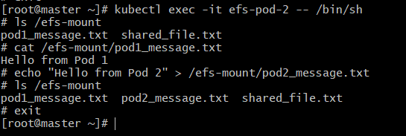

kubectl exec -it efs-pod-1 -- /bin/sh # Login back to first pod
# ls /data # List files (should see pod2's)
# cat /data/pod2_message.txt # Read file from pod 2
# exit # Exit container

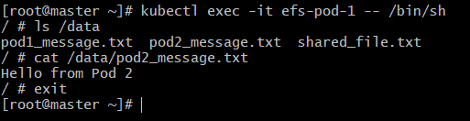

Purpose of the task:
This task demonstrates the power of Amazon EFS as shared storage for Kubernetes. Unlike EBS, EFS supports the ReadWriteMany access mode, allowing multiple pods (even on different nodes) to read and write to the same file system concurrently. This makes EFS an excellent choice for distributed applications, content management systems, shared logs, or any scenario where multiple instances need access to a common data store.

- Implement and Test Liveness and Readiness Probes in a Kubernetes Pod

Explanation:
This task demonstrates how to configure Liveness and Readiness Probes for a Kubernetes pod.
Liveness probes determine if the application inside the container is running and healthy. If a liveness probe fails, Kubernetes will restart the container. This helps in recovering from deadlocks or unresponsive processes.
Readiness probes determine if the application is ready to serve traffic. If a readiness probe fails, Kubernetes will remove the pod from service endpoints, preventing traffic from being routed to it until it becomes ready again. This ensures that only healthy and fully initialized pods receive user requests.

YAMLs:
liveness-readiness-pod.yaml
apiVersion: v1
kind: Pod
metadata:
name: probe-pod
spec:
containers:
name: my-nginx-app
image: nginx
ports:
containerPort: 80
livenessProbe:
httpGet:
path: /
port: 80
initialDelaySeconds: 15
periodSeconds: 10
timeoutSeconds: 5
failureThreshold: 3
readinessProbe:
httpGet:
path: /index.html
port: 80
initialDelaySeconds: 10
periodSeconds: 5
timeoutSeconds: 3
failureThreshold: 1

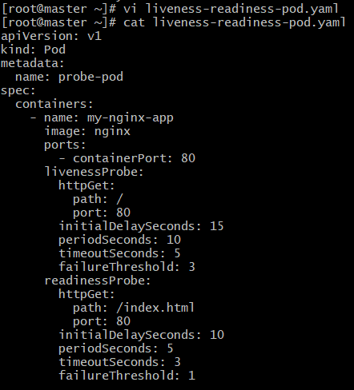

Commands:
kubectl apply -f liveness-readiness-pod.yaml # Create the Pod
kubectl get pods probe-pod -o wide # Observe initial pod status
kubectl describe pod probe-pod # Describe pod for probe details
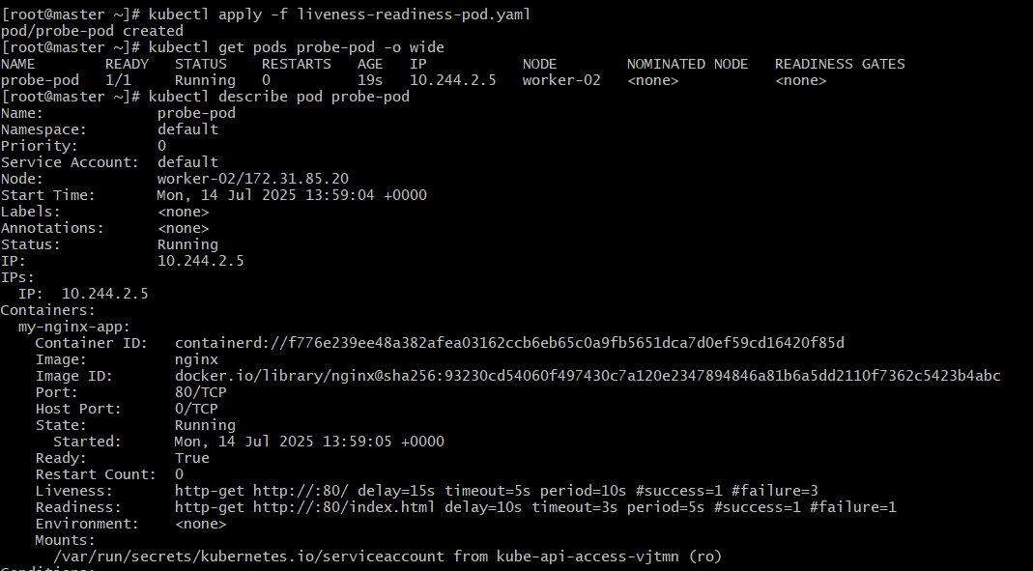

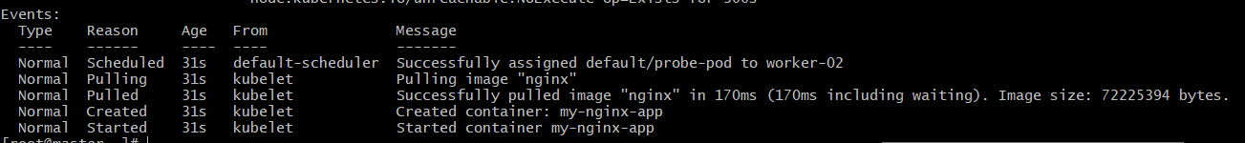

# Test Liveness Probe
kubectl exec -it probe-pod -- /bin/bash -c "nginx -s stop" # Stop Nginx to fail liveness
kubectl get pods probe-pod -w # Observe pod restarts

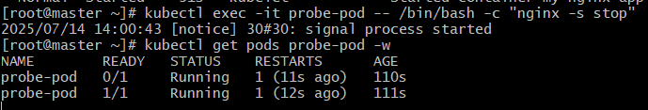

Customising the yaml file by adding # to Liveness to make, it’s attributes as comments to execute readiness successfully.

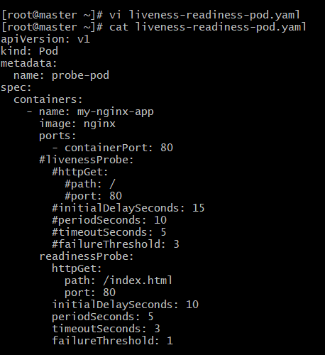

# Test Readiness Probe
kubectl get pods probe-pod -o wide # Wait for pod to be Running and Ready
kubectl exec -it probe-pod -- /bin/bash # Login to pod
# rm /usr/share/nginx/html/index.html # Delete index.html to fail readiness
# exit # Exit container

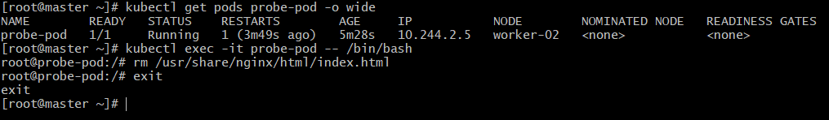

kubectl get pods probe-pod -o wide # Observe pod status (should be 0/1 Not Ready)
kubectl exec -it probe-pod -- /bin/bash # Login to pod
# echo '<html><body><h1>Welcome to Nginx!</h1></body></html>' > /usr/share/nginx/html/index.html # Restore index.html
# exit # Exit container
kubectl get pods probe-pod -w # Observe pod status (should be 1/1 Ready)

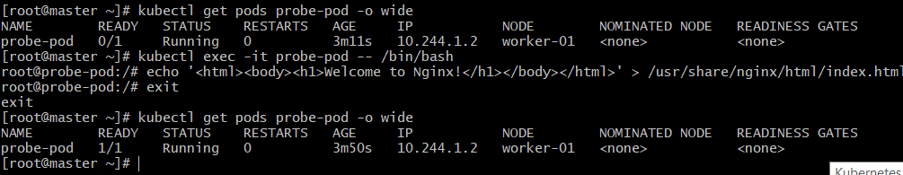

Purpose of the task:
This task highlights the importance of Liveness and Readiness probes for maintaining application health and availability in Kubernetes. Liveness probes ensure that containers are restarted when they become unhealthy (e.g., application crashes, deadlocks), preventing unresponsive services. Readiness probes ensure that traffic is only directed to pods that are truly ready to handle requests, preventing clients from encountering errors from uninitialized or overloaded application instances. Together, they contribute to the self-healing capabilities and robust traffic management of Kubernetes.

THE-END

